**<FİRMA İSMİ>**

**PCB QUOTATION REQUEST FORM**

**General Features**

|  |  |
| --- | --- |
| Quantity | 10 |
| IPC Class | 2 |
| Solder Mask Color | Green |
| Silk Screen Color | White |
| Panelization | 2 x 2 |
| Impedance Control | Yes (see pg.: …) |

**Stackup**

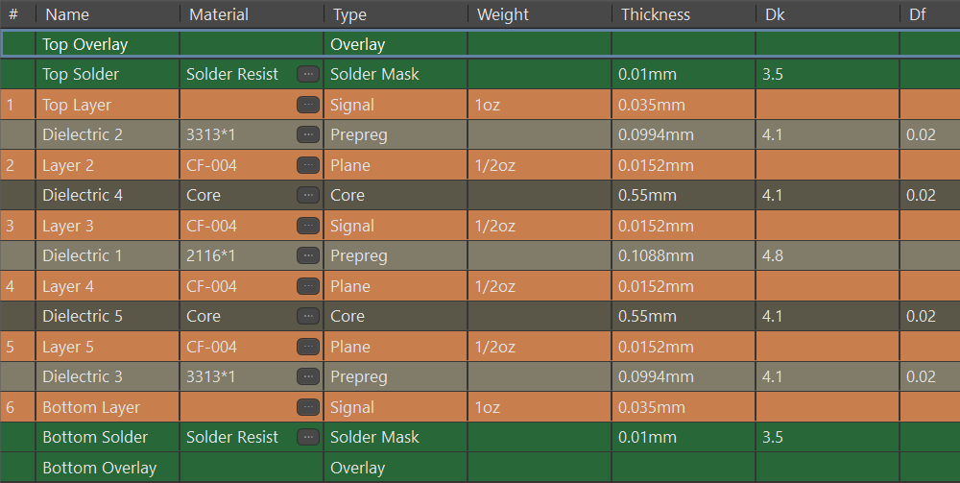

**Copper Layer Order**

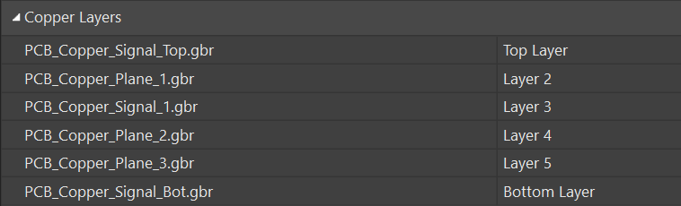

**Board Profile**

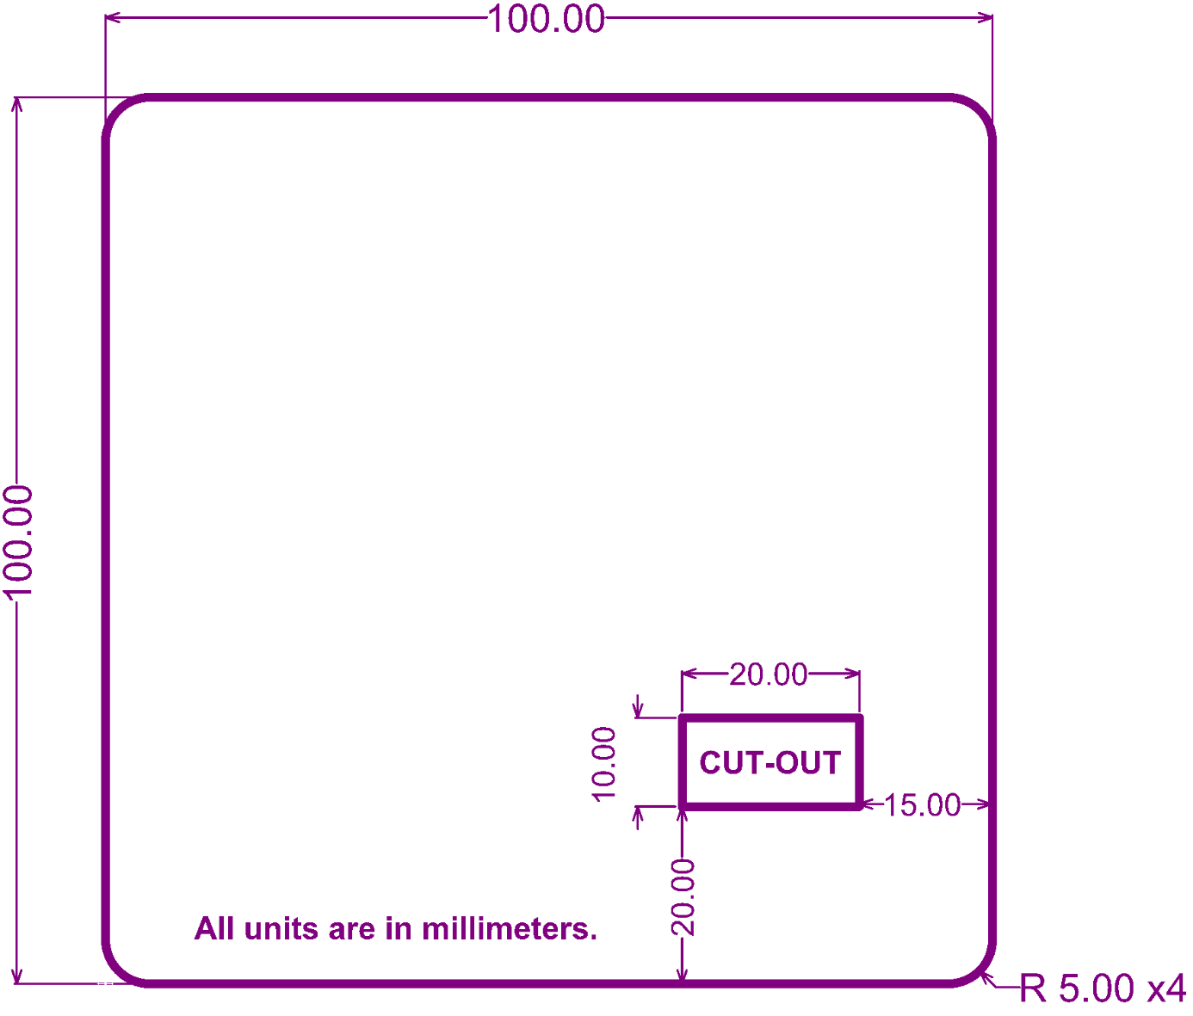

**Impedance Profile**

|  |  |  |  |  |  |  |
| --- | --- | --- | --- | --- | --- | --- |
| **Name** | **Type** | **Layer** | **Top Ref** | **Bot Ref** | **Impedance** | **Tolerance** |
| CAN | Differential  Pair | L1 | --- | L2 | 120 | 10% |
| L3 | L2 | L4 | 10% |
| L6 | L5 | --- | 10% |
| DDR Data | Single Ended | L1 | --- | L2 | 50 | 10% |
| L6 | L5 | --- | 10% |
| DDR Clock | Differential  Pair | L1 | --- | L2 | 100 | 10% |
| L3 | L2 | L4 | 5% |
| L6 | L5 | --- | 10% |
| RF | Single Ended | L1 | --- | L2 | 50 | 5% |